Package creation via VS Code

1. Install AL Language extension

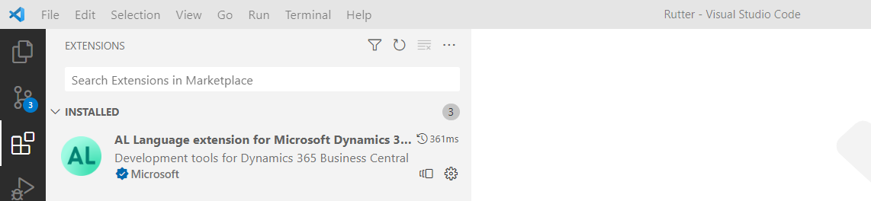

2. Open folder with Rutter extension in VS Code

3. Run View -> Command Palette -> AL: Package statement

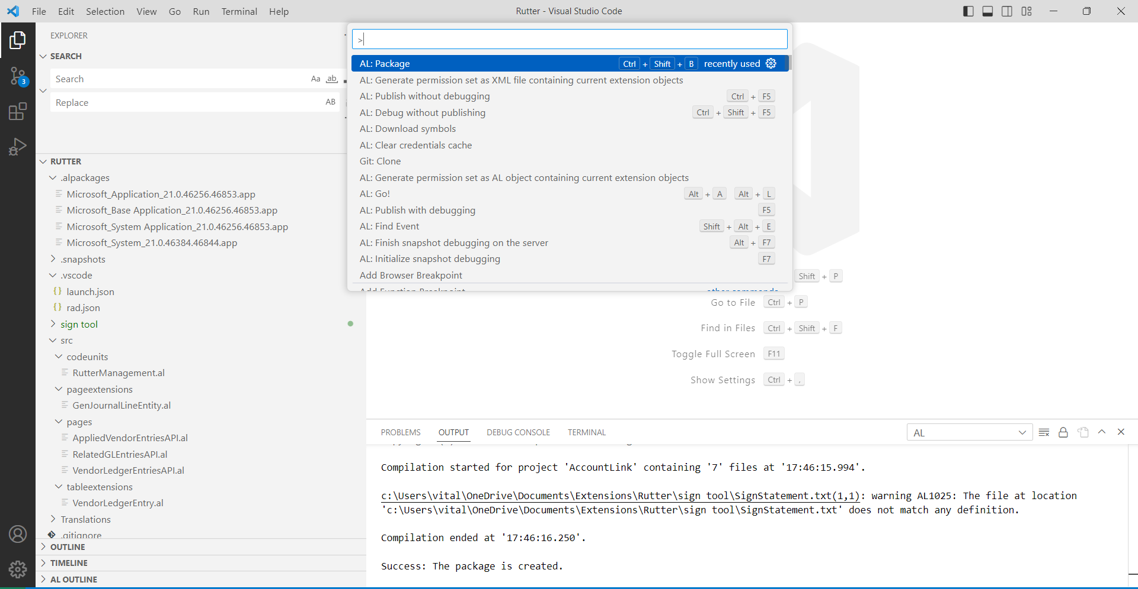

Digital sign of App file via SingTool

Run the statement below from a command prompt:

SignTool sign /debug /fd sha256 /f C:\Temp\Cert.pfx /p CertPassword /t http://timestamp.digicert.com "C:\Temp\Rutter_AccountLink_22.0.0.0.app"

Cert.pfx - certificate purchased from a Certification Authority (for instance from DigiCert <https://www.digicert.com/signing/code-signing-certificates>)

